Data 30.11.2016 Name Todoran Ana Corina – Group 917

Problem statement:

An application implement for:
  - arithmetic operations: addition, subtraction, multiplication and division by one digit, in a base p∈{2,3,...,9,10,16}
  - conversions of natural numbers between two bases p, q∈{2,3,...,9,10,16} using the substitution method or successive divisions and rapid conversions between two bases p, q∈{2, 4, 8, 16}.

Calculator - Feature list

F1. Add two real numbers in a certain base
F2. Substract two real numbers in a certain base
F3. Multiply a real number with a one digit number
F4. Divide a real number with a one digit number
F5. Convert a real number from base b into base h

Iteration plan
Iteration | Planned features
I1 | F1. Add two real numbers in a certain base  F2. Substract two real numbers in a certain base  F3. Multiply a real number with a one digit number  F4. Divide a real number with a one digit number
I2 | F5. Convert a real number from base b into base h  1. Substitution method  2. Successive divisions and multiplications  3. Rapid conversions

Iteration 1

Running scenario

First run of application:
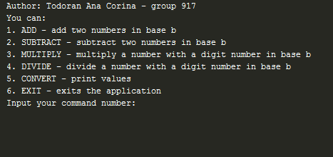

- Add two numbers in base b:
- Both numbers are positive: 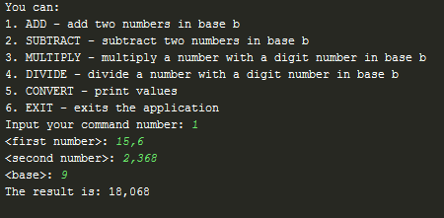

- Both numbers are negative: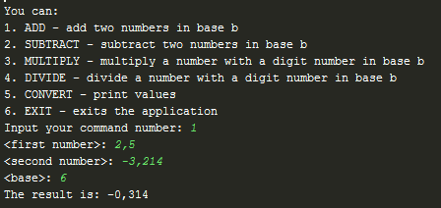

- First number is positive and second number is negative: 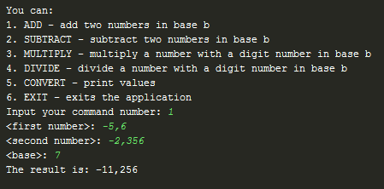

- First number is negative and second number is positive: 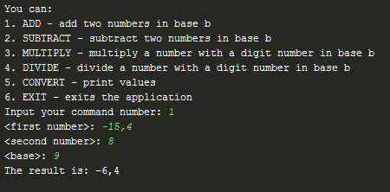

- Substract two numbers in base b:
- Both numbers are positive: 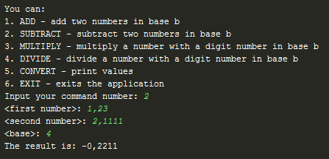

- Both numbers are negative: 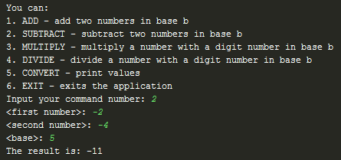

- First number is positive and second number is negative: 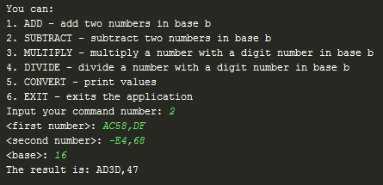

- First number is negative and second number is positive: 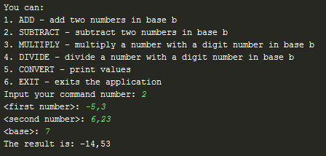

- Multiplication of a number with another one digit number in base b:
- Both numbers are positive: 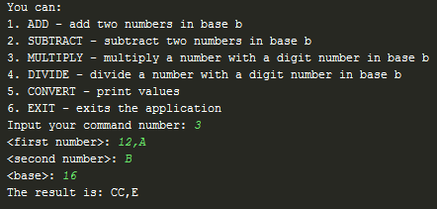

- Both numbers are negative:
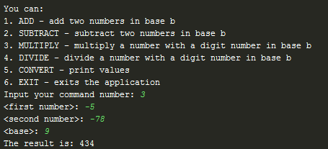

- One number is positive and the other number is negative: 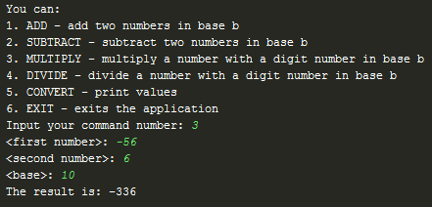

- Division of a number with another one digit number in base b:
- Both numbers are positive: 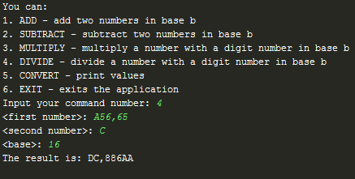

- Both numbers are negative: 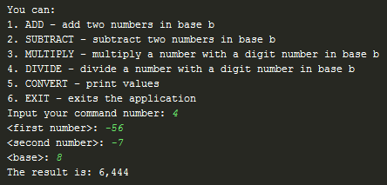

- One number is positive and the other number is negative: 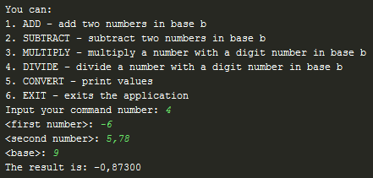

Conversion of a number from a base b into a base h:
- Base b < h and we use substitution method as follows: 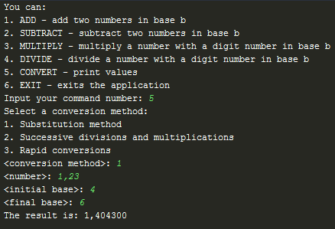
- Base b > h and we use successive divisions and multiplications method as follows: 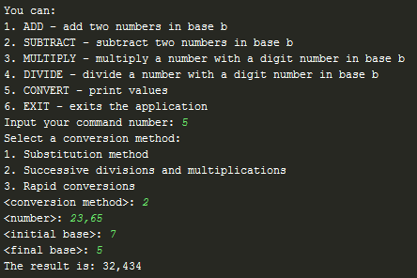

- Base b, h are from the following list {2, 4, 8, 16} and we can also use rapid conversions: 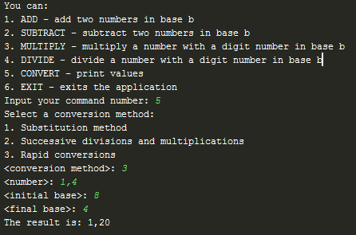

Work items/tasks
T1 | Implement the arithmetic operation: addition, substraction, multiplication, division
T2 | Implement conversion of any number in base 2
T3 | Implement conversion of any number using following methods: substitution method or successive divisions or rapid conversions between two bases p, q∈{2, 4, 8, 16}.

